Al Imam Mohammad Ibn Saud Islamic University

College of Computer and Information Sciences

Information SystemsDepartment

Course Title: | Systems Analysis and Design
Course Code: | IS 1235
Academic Year: | 1 ^{st} semester 2025-26
Course Instructor: | Male: Dr. Abdulaziz Alsahli, Dr. Usman Khalid, Prof. Hatem Ibrahim,  Female: Dr. Halah Al-Ashaikh, Dr. Lulu Alhamdan, Dr. Omaima AlMustawi, Ms. Najla Alhasoun
Assignment | Group Project
Marks: | 20
Due Date: | 13-12-2025
Project Title: | Almotasuq
Section | 172

Agreement:
- It was me and my team members NOT external party who performed this project.
- I participated with the group members to accomplish this project effectively and almost equally.
- This project is totally free from copy and any type of cheating from other Students’ works and projects.
- This project is free from illegal copy from any resources and intellectual property breaches.
Based on above I sign below and I accept any corrective action taken in case I breach or don’t fulfil the above commitments.

Student Name | Student ID | Section No. | Signature
Anas Salem M. AL-jarad | 441013178 | 172 | Accepted
Rakan Khalid Alfadhel | 444003360 | 172 | Accepted
Mohammed Adel Bahamdein | 445007935 | 172 | Accepted
Omar Khalid Al-Mazrou | 444004804 | 173 | Accepted
Abdullah Alhumaid | 444000638 | 173 | Accepted

Chapter 1: Introduction

Project Overview
Almotasuq is a mobile application for enhancing the daily life activities of Customers by providing a platform for obtaining exclusive discounts and offers.
The app encompasses a wide range of services, including food, fitness centers, electronics, and online courses, Aiming to reduce the financial pressure that Customers often face.
Functioning as a digital Customer ID, Almotasuq eliminates the need for physical cards, allowing Customers to verify their Customer status directly through their smartphones. The app features an interactive map to detect near offers, that helps Customers save their time and promote smarter spending habits.
By simplifying access to offers and supporting everyday needs, Almotasuq enhances the overall Customer experience, making it more affordable, practical, and enjoyable.

Chapter 2: Methodology
  - Project Lifecycle

Almotasuq is an app that constantly evolves and requires frequent updates for offers and discounts across various areas, as well as new partnerships.
Therefore, we’ll use the Agile Development Technique that provides flexibility and speed in adjustments while maintaining continuous focus on the user.
Agile supports iterative development, which allows us to develop small parts of the app in stages and release them gradually. This enables us to release features quickly, ensuring rapid adaptation to changes and faster time to market.
As well as, it focuses on continuous interaction with customers, whether through their feedback and evaluations or by tracking their daily use of the app, which helps in continuously improving the app. All of this makes Agile the most suitable methodology for Almotasuq.

  - Team Member’s Responsibilities

Table 1 Student’s ..
Responsibilities Tasks | Student Responsible for
- Class Diagram  - Conclusion  - Interfaces Design  - Presentation Slides | Abdullah Mohammed Alhumaid
- Methodology  - Functional &Non-functional requirement  - BPMN | Anas Salem Aljarad
- Use Case Diagram  - Use Case Description  - CRC Card | Rakan Khalid Alfadhel
- DFD  - State Machine Diagram  - Deployment Diagram | Omar Khalid Al-Mazrou
- Activity diagram  - Object diagram  - Sequence diagram | Mohammed Adel Bahamdein

Chapter 3: System Analysis

  - Introduction
Almotasuq is a mobile application designed to simplify access to exclusive discounts and offers across various sectors, including food, fitness, electronics, and online courses. It provides an interactive map to locate nearby deals. Its goal is to enhance convenience, reduce financial pressure, and promote smarter spending habits for users.

  - Requirements Definition

    - Functional Requirements
      - The customer shall be able to register using a personal email and phone number.
      - The system shall validate whether the email is a valid or not by email verification.
      - The system shall enable anyone to browse the application as a guest, but they will have no access to the exclusive discount code.
      - The customer shall be able to browse offers by categories.
      - The customer shall be able to rate and view other customer’s ratings.
      - The customer shall be able to view and claim available prizes.
      - The system shall display new shops on Almotasuq with discounts.
      - The system shall display a list of available offers and discounts.
      - The system shall display offers based on the user’s location.
      - The system shall display the trending shops.
      - The system shall display cashback shops with percentage.
      - The system shall generate a discount code for each offer that has a time limit to use.
      - The admin shall be able to view, add, edit, or delete both active and expired offers.
      - The admin shall be able to approve or reject offers.
      - The admin shall be able to manage user accounts.
      - The admin shall be able to send notifications and alerts.
      - The service providers shall be able to create and edit their offers.
      - The service providers shall specify the branches where the discount code can be used.
      - The service providers shall assign conditions and terms to each discount code which must be met.
      - The service providers shall confirm discount codes.
    - Non Functional Requirements
      - The system shall support both languages (Arabic and English).
      - The system shall be easy to use for customers.
      - The system shall support at least 10,000 users at the same time.
      - The system shall ensure data integrity.
      - The system shall provide customer support 24/7.

  - Functional Busniess Process Modeling
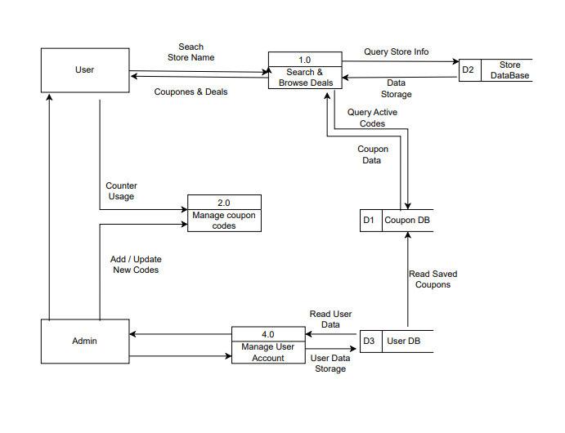
    - DFD

    - BPMN
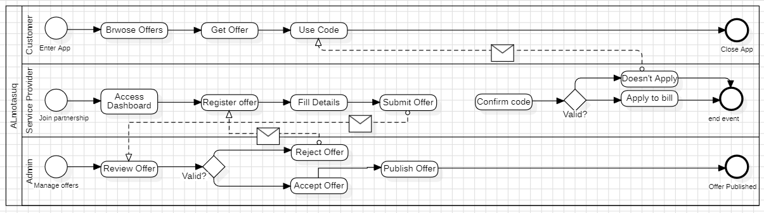

    - Use Case diagram

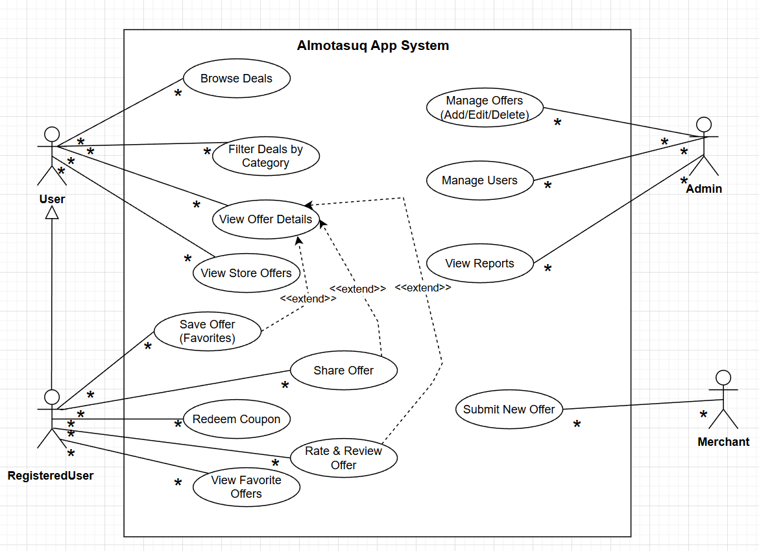

    - Use-Case description

Use case name: View Offer Details | Id: UC-01 | Importance level: High
Primary actor: User | Use case type: Detail, Essential
Stakeholders and interests:
- User: is interested in seeing complete and accurate information of an offer.
- Registered User: could be willing to make some extra (save, share, review) actions.
- Merchant: requires an accurate display of their offer details.
- Admin: desires the system to be the source of correct and updated offer information.
- System: should be able to get and present the correct offer details in an efficient manner.
Brief Description: Essentially, the use case illustrates a user selecting an offer and viewing all the related details, These include title, description, discount, expiration date, store information, and terms.
Trigger: The user selects an offer from the list of deals or categories.
Type: External.
Relationships:
Association: User.
Include: None.
Extend: Save Offer (Favorites), Share Offer, Rate & Review Offer.
Generalization: None.
The normal flow of events:
1- The user browses through the list of available deals.
2- The user clicks on a particular offer to get more details.
3- The system fetches the detailed offer information from the database.
4- The system presents the offer title, discount amount, description, expiration date, store name, and terms.
5- The system displays extra features (if the user is registered): Save, Share, Rate & ​‍​‌‍​‍‌Review.
Subflow: None.
Alternate/ Exceptional flows: A1-Offer not found
1- The system fails to retrieve the offer details.
2- The system displays an error message: “Offer not available.”

    - Activity diagram

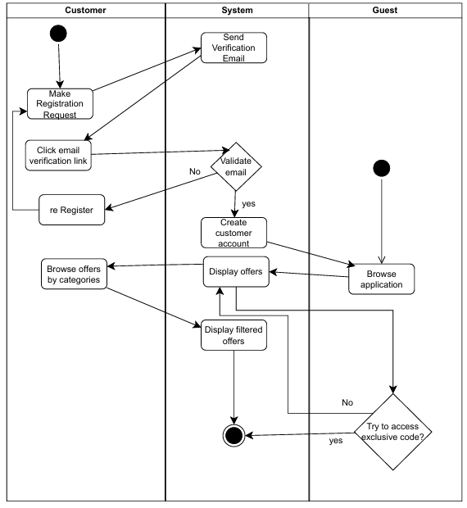Figure 1(Registration &Access flow)
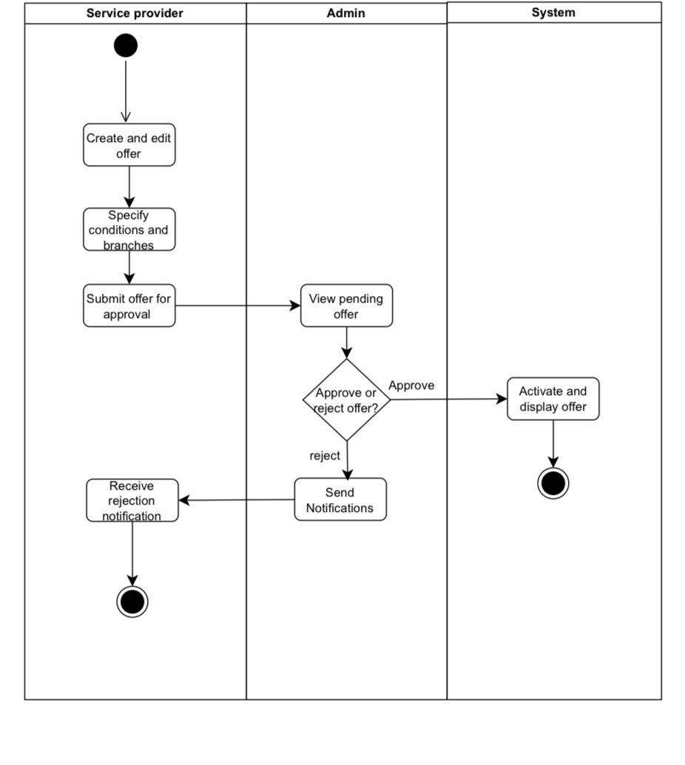
Figure2(Offer management flow)
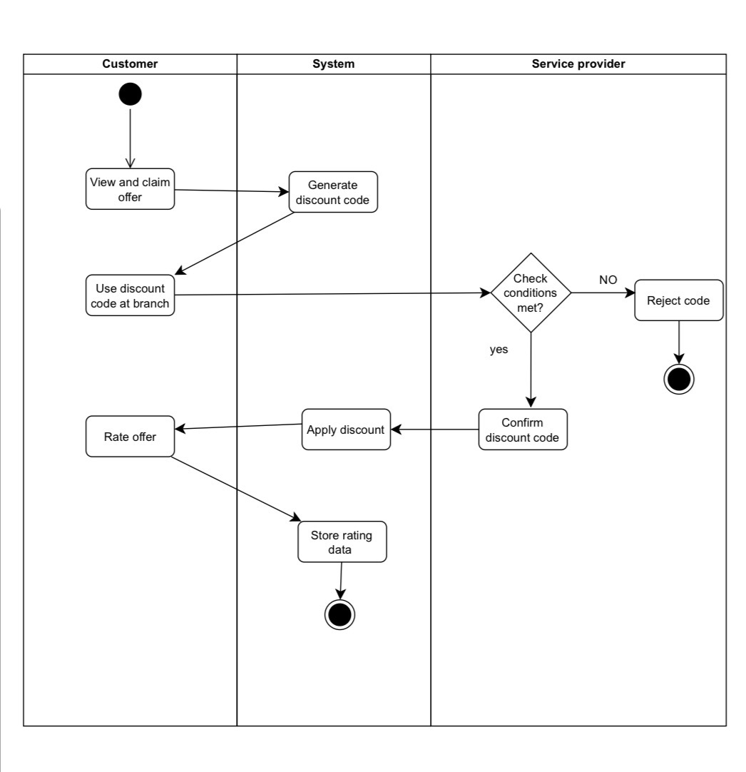

Figure3(Claiming & Rating Flow)
  - Structural Modeling

    - Class Diagram
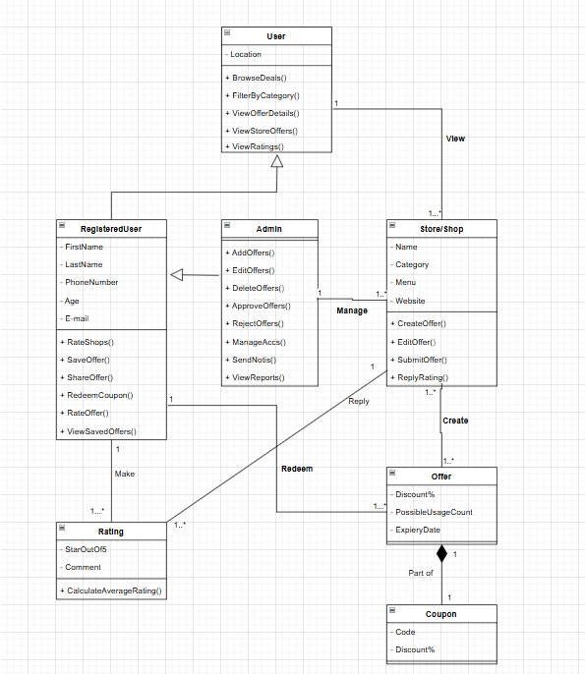

    - CRC card
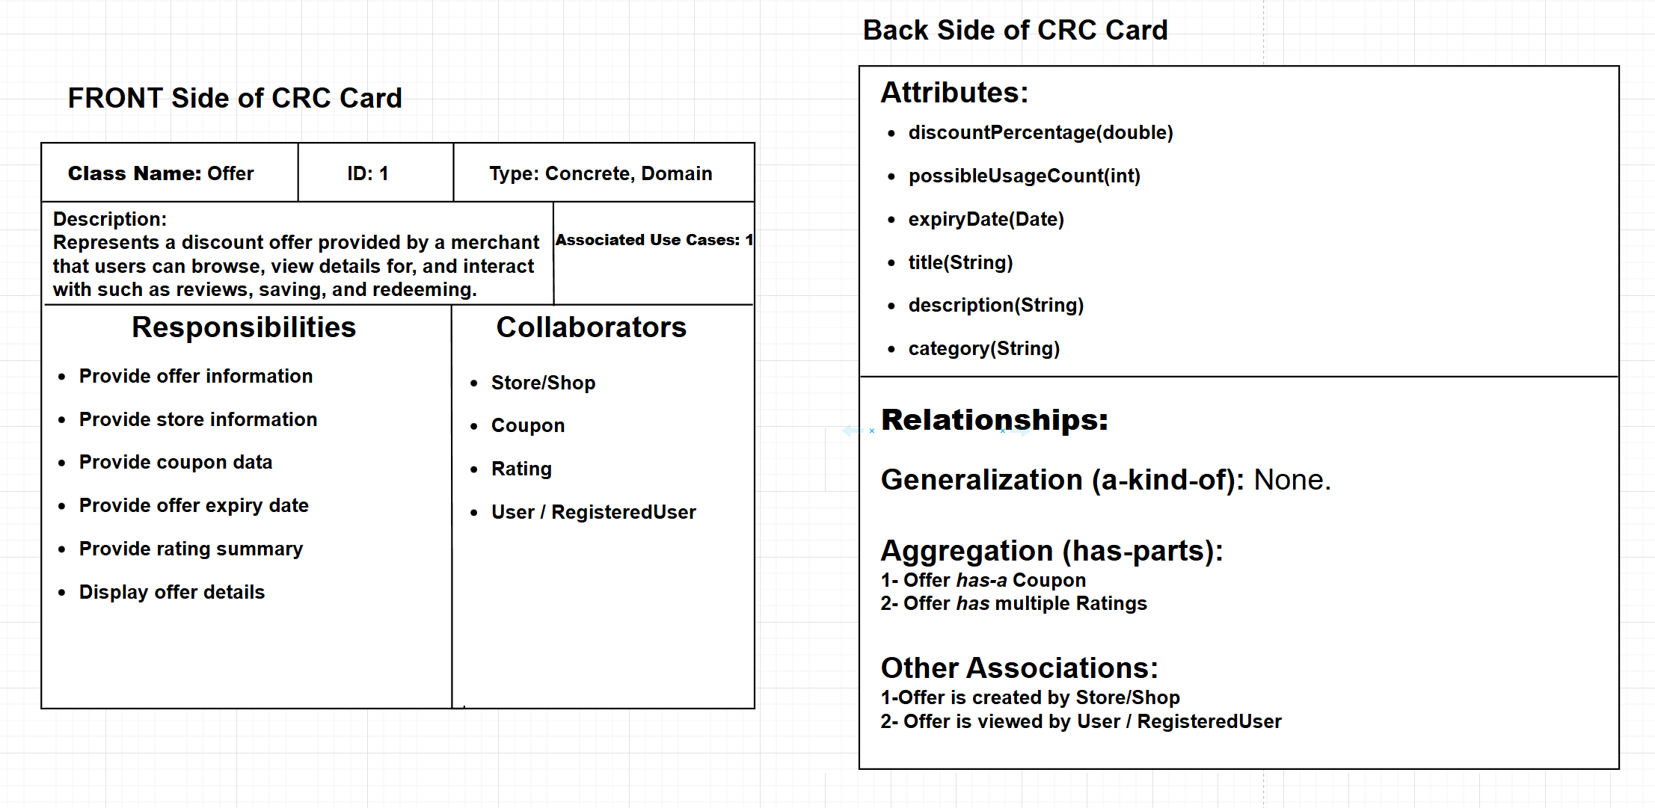
    - Object Diagram
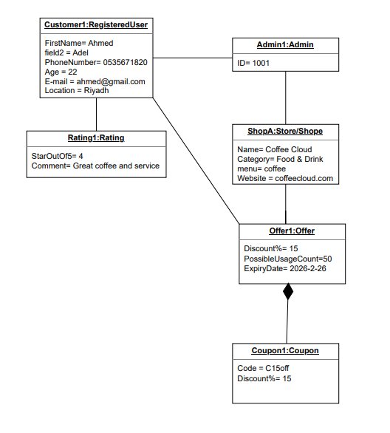
  - BehavioralModeling

    - Sequence diagram
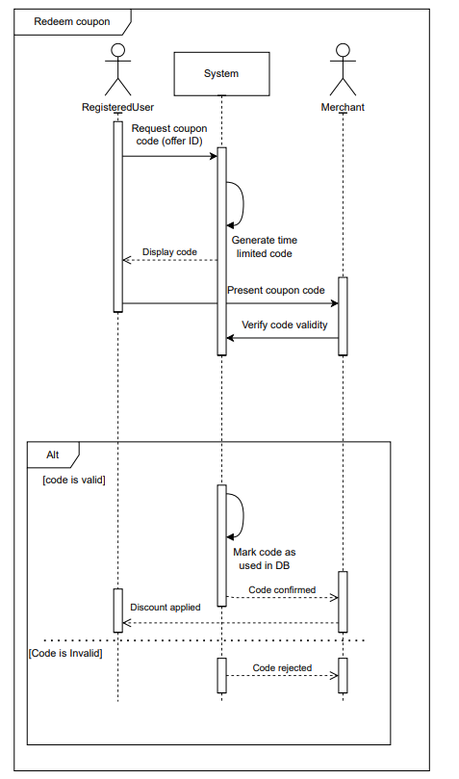

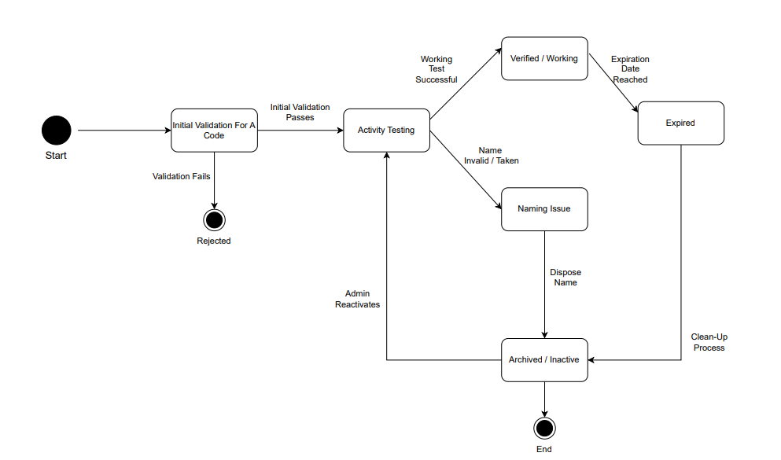
    - Behavioral state machine for any complex object

Chapter 4: System Design

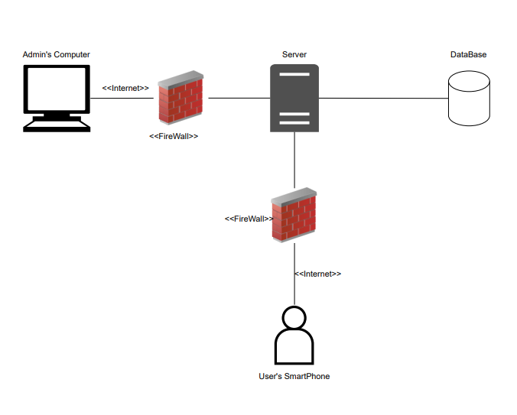
    - Deployment-diagrams
    - User Interfaces Design

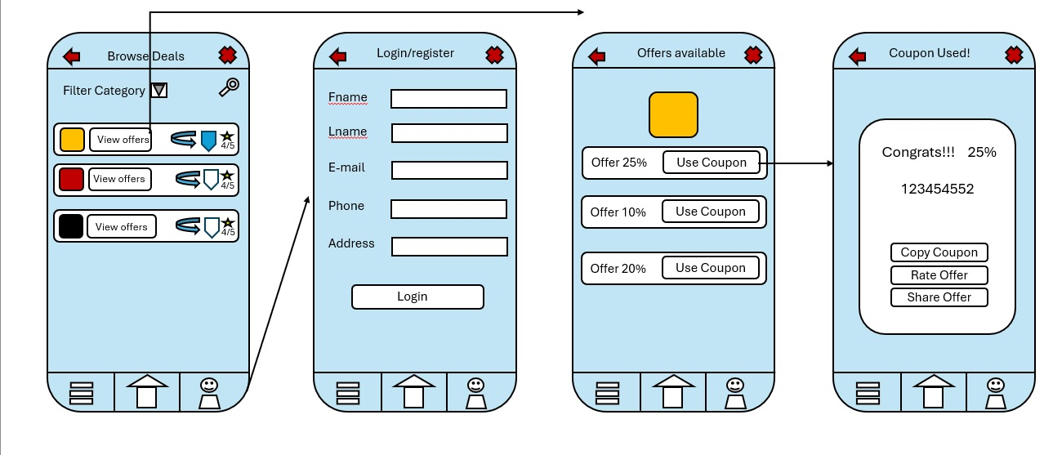

These intefaces sums the system usage, first one is the Home page which is the page for browsing the shops to get the offers wanted you can search, filter categories, save, share, and view the ratings, to be eligible to get the offer a login is required which gets us to the second interface which is a basic filling of login/register information, after logging in and pressing the view offer button next to the shop wanted, the third interface appears and user can choose which offer to get by pressing the Use Coupon button next to the offer wanted, the fourth interface appears after that a pop-up appears where the coupon appears and you can copy it with one button, rate the offer or share it.

Chapter 5: Discussion and Conclusion

This project presented the analysis and design of Almotasuq, an app takes offer from multiple sides of the internet and get them in one place, The system was designed to save time and money for the users in only one place with features like saving and copying the offers instantly.
With using Agile methodology, the design can be flexible with constant improving and taking feedback, which are important for apps that always change its contents with the offers and such, The system analysis defined clear functional and non-functional requirements, making sure that the application meets user needs while keeping performance, usability, and reliability.
The system designed show how users, shops and admins interact with the app, overall, Almotasuq shows howgood you can design A system using real world examples. This project highlights the importance of clear requirements, strucured modeling, and user centered design in building effective information systems.

